EDLINE Activation Instructions

1. Log on to the computer.

If you do not have your login information, please inform your teacher immediately. Please know you will not be able to continue without that information.

1. Click on “My Computer” in the school menu.
2. Double click on the “Hand Out” icon
3. Double click on the folder named “Filano”
4. Double click on the folder named “Period 2”
5. Double click on the “Welcome to Edline.net” link

You should now see a webpage that looks like this:

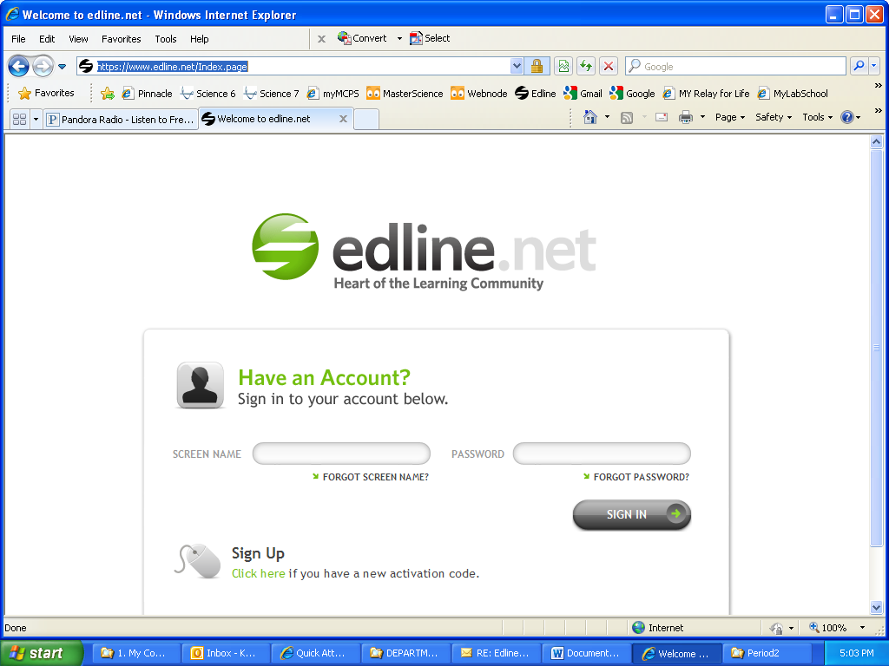

Turn this page over for more directions…

Activation Time!

1. Click on “Click here” underneath where it says “Sign Up” on the Edline.net home screen.

YOUR TEACHER WILL NOW HAND OUT YOUR EDLINE ACTIVATION CODE.

BE SURE YOUR SLIP OF PAPER HAS YOUR NAME ON IT!

1. Type in your activation code exactly how you see it on the slip of paper your teacher gave you. Yes—you need to put the dashes in too.
2. Press Enter.
3. You should now see your name under where it says, “Second: Make sure each code you have entered is yours”
4. Click “Activate this Code”
5. Click “I Agree” on the next page.
6. [](http://www.clipartguide.com/_pages/0008-0710-1822-5545.html)You will now be prompted to enter a Screen Name and Password – VERY IMPORTANT:

**YOU MUST ENTER THE SAME USERNAME FOR EDLINE THAT YOU USE TO GET ONTO THE COMPUTERS AT LPMS. YOU MAY CHOOSE YOUR OWN PASSWORD.**

1. After you have entered your screen name and password, click “Enter”
2. You will be prompted to enter an email address. If you have an email address, go ahead and enter it now. If you do not have an email address, you can skip this step.
3. Choose a security question (either from the drop down menu, or create one yourself)
4. Be sure to enter the correct answer.
5. Click “Save and Return”
6. You should now see the LPMS Edline homepage

YOU ARE NOW REGISTERED ON EDLINE!

You will not need your activation codes anymore. Now, you can simply sign into Edline using your username and password.